SOLO6010 Bug Report

1. PCI Read/Write Operation Bug
1) Situation
If the clock interval of 2 register read/write operations is less than 3, PCI core of SOLO6010 outputs STOP signal continuously and stops operation.

2) Solution
Read PCI configuration register after normal register read/write operation.

2. MPEG, JPEG Encoding Buffer Bug
1) Situation
If the last encoded data position in external buffer reaches near buffer boundary, and the last encoded data position plus the size of current encoded data exceeds the size of external buffer, exceeded data portion is written from the beginning of external buffer. If the size of this exceeded data portion is greater than 64KByte, next encoded data overwrites this. (Figure 1)
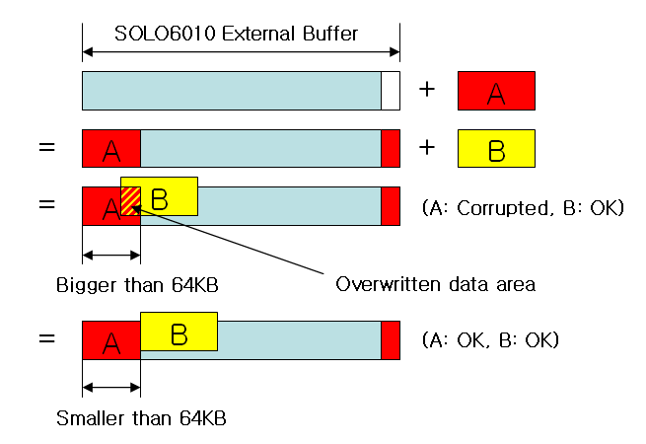
Figure 1) MPEG, JPEG encoding problem
2) Solution
(1) When this situation happens, discard overwritten frame data, and reset GOP of corresponding channel.
- GOP Reset
Step 1) Write 1 to GOP register. (Set GOP to 1)
Step 2) Check whether current frame is I or P in ISR. If current frame is P, discard. If current frame is I, go to next step.
Step 3) Write original GOP value to GOP register and restart recording.

(2) Manage the size of encoded frame data by CBR control. Set QP always above 2 and if the size of encoded frame data exceeds 64KByte, increase QP.

3. JPEG Quality Bug
1) Situation
When using JPEG QP 1 and 3, sometimes encoded image is corrupted on complex source image.

2) Solution
In JPEG encoding, use only QP 2.

4. SDRAM 32bit Interface Bug
1) Situation
When using SDRAM interface as 32bit mode, data error occurred.

2) Solution
Use SDRAM interface as 64bit mode. (You cannot use 32bit interface mode.)

5. SDRAM Data Error When System Clock Is 108MHz
1) Situation
If system clock is 108MHz, data error exists when SDRAM read/write operation.

2) Solution
Set system clock as 104MHz.
PLL setting value about 104MHz system clock
- INPUTDIV : 25
- FEEDBACKDIV : 206
- OUTDIV : 3

6. Video OSG Rightmost 1 Vertical Line Is Not Displayed
1) Situation
Video OSG rightmost 1 vertical line is not displayed.

